**One Way ANOVA - Worked Example**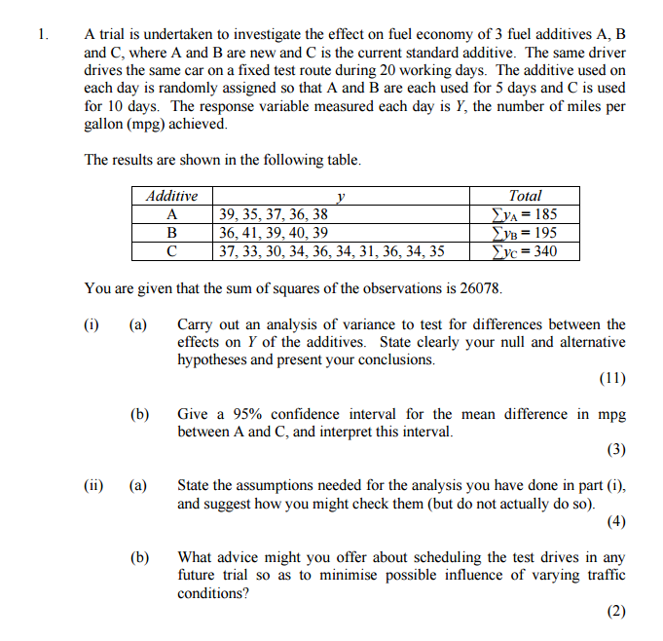

You are given the additional piece of information , sufficient to construct ANOVA table

|  |  |  |  |  |
| --- | --- | --- | --- | --- |
|  | **A** | **B** | **C** | **Total** |
| **mean** | **37** | **39** | **34** | **36** |
| **std. deviation** | **1.5811** | **1.8708** | **2.2111** | **2.8837** |

**Solution to One Way ANOVA Table**

* Additives: Between Groups
* Residuals : Within Groups

